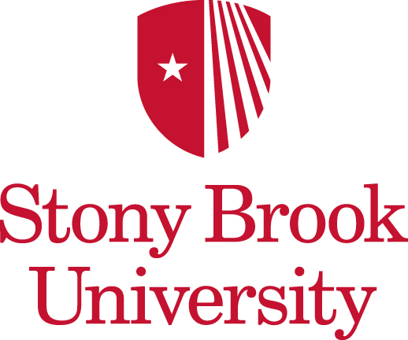

MEMO

Date: June 6, 2012

To: Pohang University of Science and Technology

From: William Arens, Ph. D., Dean, International Academic Programs

Subject: Student Exchange Agreement & POSTECH/CITE-SBU/CEAS Annex between Stony Brook University and POSTECH

Attached is a copy of the MOU and Exchange Agreement for signatures by Northumbria University personnel. Upon signing, please courier a copy to SBU to keep for our records.

If you should have any questions, please contact me at 631-632-7030.

Thank you.

.0+

